**Assignment # 1**

**K20-1052**

1. **List up to 10 different protocols that appear in the protocol column in the unfiltered packet-listing.**

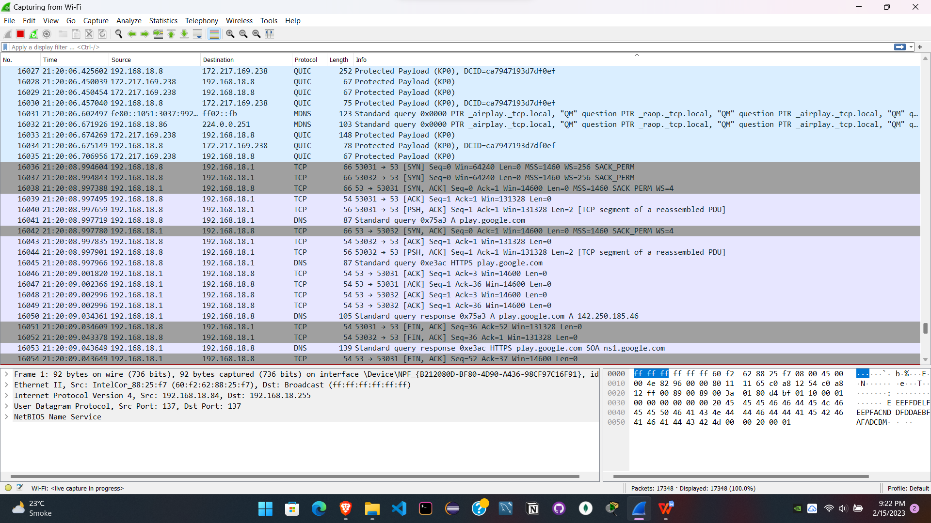



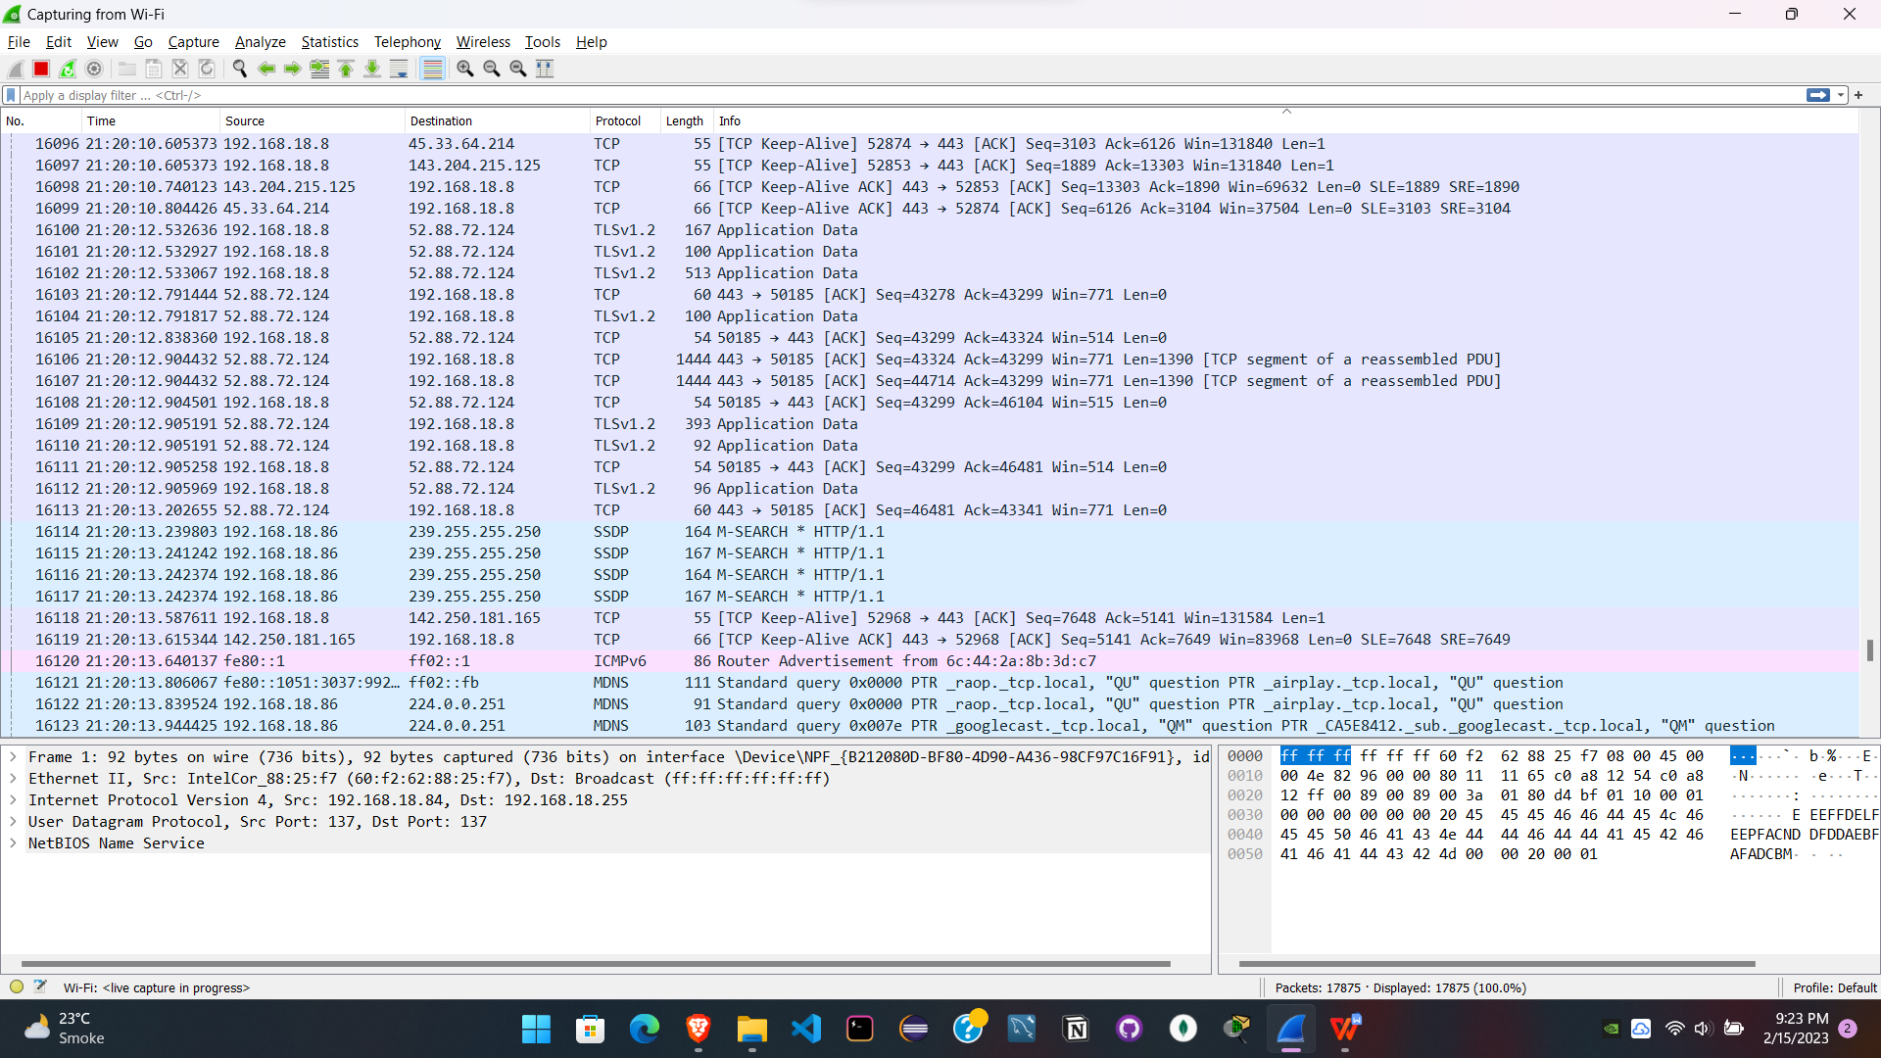



Unfiltered ones inluded:

1. TCP
2. UDP
3. DNS
4. QUIC
5. MDNS
6. SSDP
7. ICMPv6
8. TLSv1.2
9. TLSv1.3
10. HTTP
11. **How long did it take from when the HTTP GET message was sent until the HTTP OK reply was received? (By default, the value of the Time column in the packet-listing window is the amount of time, in seconds, since Wireshark tracing began. To display the Time field in time-of-day format, select the Wireshark View pull down menu, then select Time Display Format, then select Time-of-day.)**

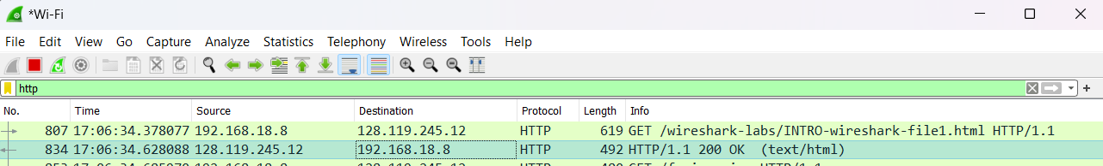

34.628088 - 34.378077 = 0.25 = 250 ms taken



**3. What is the Internet address of the gaia.cs.umass.edu (also known as www-net.cs.umass.edu)?**

**What is the Internet address of your computer?**

Destination address shows IP of gaia.cs.umass.edu: 128.119.245.12

Source address shows IP of my computer: 192.168.18.8

While making HTTP GET request 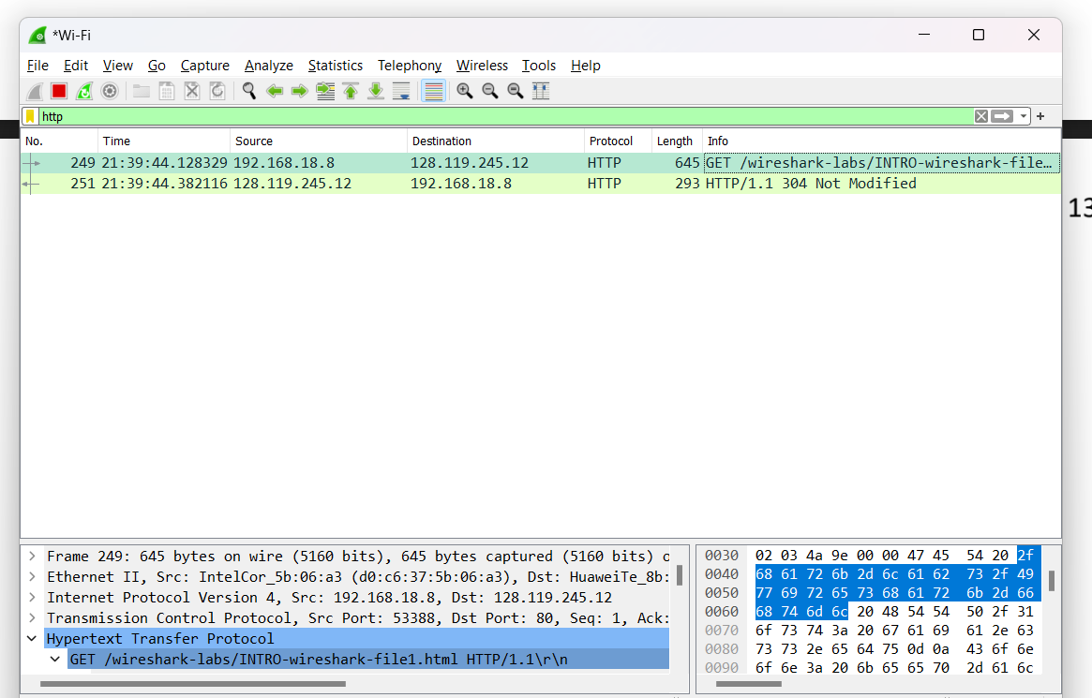



**4. Print the two HTTP messages displayed in step 9 above. To do so, select Print from the Wireshark File command**

**menu, and select “Selected Packet Only” and “Print as displayed” and then click OK.**

